Software Architecture Document
protExpress

Last Revised: | 5.22.2007
Produced By: | NCICB Development Team
Version: | 0.3

Document Approvals
The list contains the name for the core project team and any key stakeholders who have an interest in the success of the project. An “S” identifies persons responsible for approval from the Business and Development. Sign off of the document would be required when a decision is made not to take action for defined gaps.

S | Name | Role | S | Name | Role
S | Anand Basu | NCICB Engineering Manager | S | Juli Klemm, Ph.D. | Product Manager
 | Brent Gendleman | Development Project Manager |  | Jerry Eads | NCICB Project Manager
 | Eric Tavela | Development Architect |  | Ron Keene | NCICB Independent QA
 | Don Swan | NCICB Application Support
Revision History
When you make a change to a document, you must add an entry to this Revision History table and you must manually type the Last Revised Date on the front cover.

Date | Version | Description | Revised by
04/25/2007 | 0.1 | Initial draft, mostly template text with MAGE-OM design alternatives incorporated | Eric Tavela
05/15/2007 | 0.2 | Draft from Inception Iteration 1, containing basic architectural information for implemented candidate architecture. | Eric Tavela
05/22/2007 | 0.3 | Added additional content to complete draft for Inception Iteration 1. | Eric Tavela
Copyrights and Trademarks
© Copyright 2007 by NCICB, caBIGTM. All rights reserved.

Table of Contents
1. Introduction 3
1.1. Purpose 3
1.2. Scope 3
1.3. Definitions, Acronyms, and Abbreviations 3
1.4. References 3
1.5. Overview Error! Bookmark not defined.
2. Architectural Representation 4
3. Architectural Goals and Constraints 4
4. Use-Case View 4
5. Logical View 5
5.1. Overview 5
5.2. Architecturally Significant Design Packages 6
5.3. Use-Case Realizations 7
5.4. Design Approaches Considered 7
6. Process View 10
7. Deployment View 10
8. Implementation View 11
8.1. Overview 11
8.2. Layers 11
9. Data View (optional) 11
10. Size and Performance 12
11. Quality 12

Introduction

Purpose
This document provides a comprehensive architectural overview of the caArray system, using a number of different architectural views to depict different aspects of the system. It is intended to capture and convey the significant architectural decisions which have been made on the system.

Scope
This document describes the aspects of caArray’s design that are considered to be architecturally significant; that is, those elements and behaviors that are most fundamental for guiding the construction of caArray and for understanding caArray as a whole. Stakeholders who require a technical understanding of caArray are encouraged to start by reading this document, then reviewing the caArray UML model [CAARRAY_UML], and then by reviewing the source code. Please note that all diagrams represented in this document are taken from the caArray UML model [CAARRAY_UML]; for more detail about the elements in these diagrams, please consult the source model.

Definitions, Acronyms, and Abbreviations
- DAO – Data Access Object
- EJB – Enterprise JavaBeans
- J2EE – Java 2 Enterprise Edition
- Java SE – Java Standard Edition
- JDK – Java Development Kit
- JPA – Java Persistence API
- JSF – JavaServer Faces
- JSP – JavaServer Pages
- MAGE-OM – Microarray and Gene Express Object Model
- POJO – Plain Old Java Object
- RUP – Rational Unified Process
- UML – Unified Modeling Language

References
[CAARRAY _UML] caAMEL UML Models
//cm/caarray2/docs/analysis_and_design/models/caaray.eap
[KRUCHTEN] Philippe Kruchten 1995, "The 4+1 view model of architecture," IEEE Software. 12(6), November 1995.
//cm/caarray2/docs/analysis_and_design/references/architecture/Kruchten4+1.pdf
[RUP] The Rational Unified Process, Version 2003.06.13

Architectural Representation
The caArray architecture is represented in this document and in the UML design models as a set of views of the system from different but complementary perspectives. These views are:
- The Use-Case View – Describes the functional requirements of the system.
- The Logical View – Describes the organization of the system design into subsystems, interfaces, and classes and how these elements collaborate to provide the functionality described in the use-case view.
- The Process View - Illustrates the process decomposition of the system, including the mapping of classes and subsystems on to processes and threads.
- The Deployment View – Describes how the processes are allocated to hardware and execution environments and the communication paths between hardware nodes.
- The Implementation View – Describes the software components that realize the elements from the logical view and the dependencies between these components.
This style of describing software architecture is the approach recommended by the Rational Unified Process and is based on Philippe Kruchten’s work, “The 4+1 view model of architecture” [KRUCHTEN] and is refined in the Rational Unified Process [RUP].

Architectural Goals and Constraints
The following factors are key considerations beyond the functional requirements that are guiding the design of caArray 2.0.

caBIG Silver/Gold Compliance
caArray must be implemented in such a way that it may be certified caBIG Silver compliant. Furthermore, caArray will provide a grid interface and any other qualities that are expected to be required for Gold compliance when the compliance criteria are finalized.

Remote API Usability
One of the major flaws in earlier releases of caArray has been the requirement to use the MAGE-OM to access annotation and data. Navigation between key classes in the MAGE is inefficient, difficult to understand, and difficult t0 implement. The object API exposed by the new evolution of caArray must be designed to be easily-understandable and navigable by remote clients, whether they access the API via the grid or a Java programmatic interface.

High Performance Data Parsing, Storage and Retrieval
Given that data storage and retrieval is the principal functionality of caArray, array data parsing, storage, and retrieval performance is key to a successful design.

Use-Case View
In order to drive the candidate architecture exploration in the Inception iteration a single, simple business object search and update use case (Manage Protocols) was selected in order to exercise the components of the candidate architecture. This use case is not considered architecturally significant in the true sense, but is representative of use cases that require object access and update. A representation of this use case can be seen in Figure 1 below.
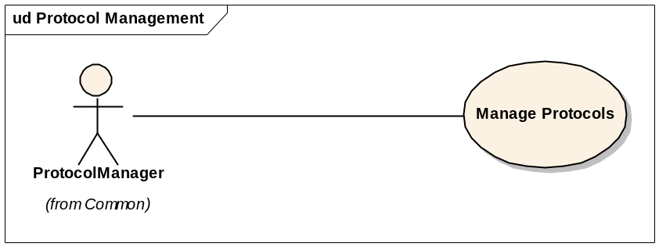
Figure 1 – Protocol Management Use-Case Diagram

Logical View

Overview
The design model (from which the logical view is taken) is the most significant model, requiring the most effort and containing the majority of the content. Accordingly, the description of the logical view of caArray’s architecture will receive the most attention here. This section of the document first describes the structural hierarchy of the system in layers, packages, and subsystems and then goes on to describe how these elements collaborate to provide the most architecturally significant functionality. Figure 1 below shows the top-level structural organization of caArray.
caArray is implemented as a J2EE 1.4 application built on top of Java SE 5 (JDK version 1.5.0_10) employing the following core J2EE technologies:
- JSP 2.0
- Servlet 2.4
- JMS 1.1
- EJB 3.0.
Only EJB session and message-driven beans are being used; persistence is being managed directly with Hibernate 3.2 rather than EJB’s persistence API (JPA). JPA provides no significant advantages over Hibernate at this point and Hibernate provides additional extended functionality not included in JPA.
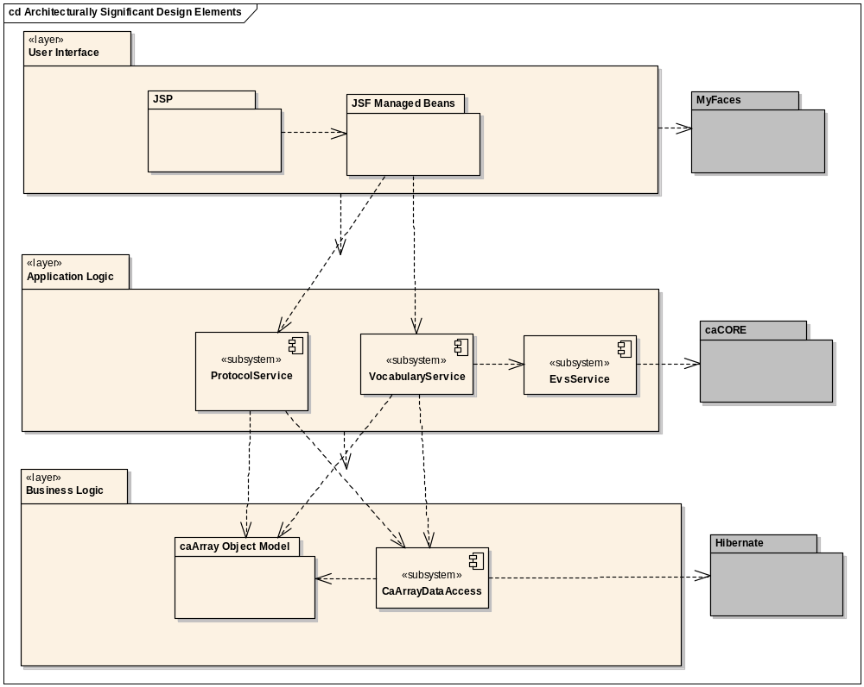

Figure 2 – Architecturally Significant Design Elements

Architecturally Significant Design Packages

User Interface Layer
caArray uses JavaServer Faces (JSF) to implement the user interface view and controller. Specifically, caArray uses the Apache MyFaces 1.1.5 implementation of JSF. Currently view pages are implemented using JavaServer Pages (JSP), but the team will explore the advantages of using Facelets over JSPs in the first Elaboration iteration.

VocabularyService Subsystem
caArray requires the use of controlled vocabularies such as the MGED Ontology. In order to provide a consistent view of external vocabularies, caArray includes a VocabularyService subsystem that manages interfacing with external vocabulary sources, provides a consistent Term and Category view of vocabularies, and manages local storage of vocabulary elements for efficiency.

caArray Object Model
The underlying business object model is implemented as a set of POJOs that model the domain of microarray experiments and data. Whereas earlier versions of caArray used MAGE-OM 1.1 as the basis for the underlying object and data model, the new caArray implementation will be based on a completely revised, simplified object model. Although MAGE-OM is a published standard, there are significant disadvantages in using it as an underlying object model; it is complicated to understand, its complexity makes data storage very inefficient, its structure does not permit many useful object graph navigations, and many common relationships can not be stored when complete experiment annotation is not available. For these reasons we have chosen to produce a new, simplified object model for domain data representation. caCORE is being used for the initial generation of these POJOs.

caArray Data Access
caArray uses the standard Data Access Object pattern to provide data updates and retrievals. The DAOs are exposed as Java interfaces accessed through a Factory class. The implementations of the DAOs use Hibernate 3.2 as the underlying persistence mechanism.

Use-Case Realizations
TBD – The Use-Case Realizations section will be written and updated as significant use cases are realized in later iterations.

Design Approaches Considered

MAGE-OM API
Consideration was given to how to support clients that rely on the current MAGE-OM API. Various design approaches were considered (shown below in Figures 3, 4, and 5). In order to provide easy support for the MAGE-OM API and to provide an easier data migration path, the initial design approach was to continue to use the MAGE-OM as the underlying object and persistence model, wrapping it with a simplified object façade (Figure 3). As the disadvantages of this approach became evident, this model was turned upside down with the resulting approach using a simplified underlying object model with a MAGE-OM object façade where the MAGE-OM objects would understand how to represent the underlying data in a MAGE-based fashion (Figure 4). Finally, in order to make the MAGE objects more flexible, the final approach took the data translation knowledge out of the MAGE objects, encapsulating it in classes that specialized in translation between MAGE objects and the simplified object model (Figure 5). It should be noted that the necessity of supporting a MAGE-OM based remote API is currently under discussion and may be dropped entirely as a feature.
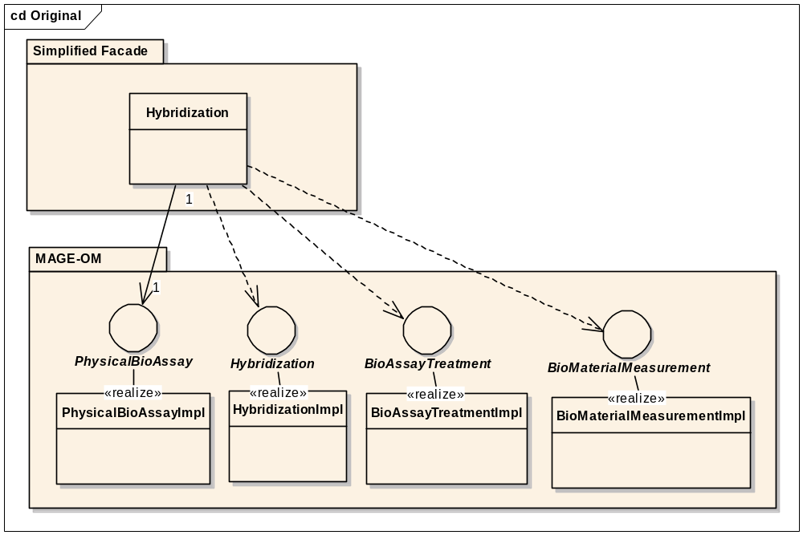
Figure 3 – Simplifying façade to MAGE-OM
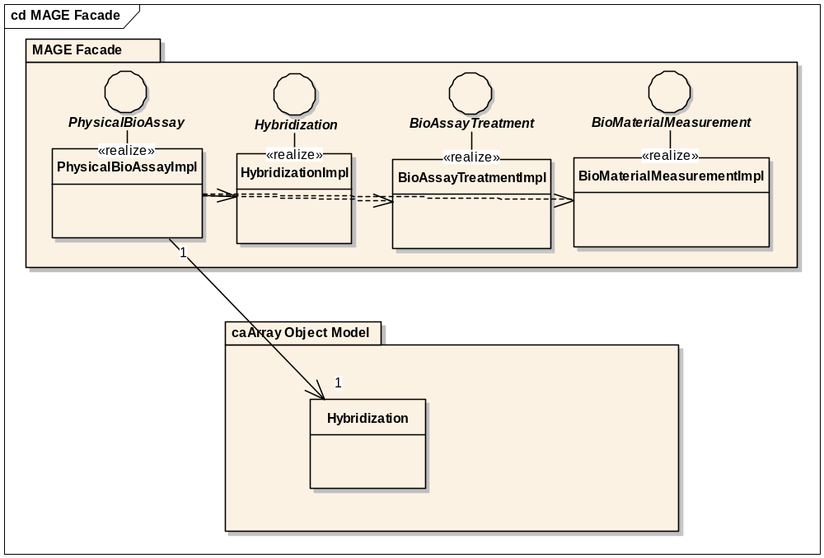
Figure 4 – MAGE-OM façade to simplified caArray object model

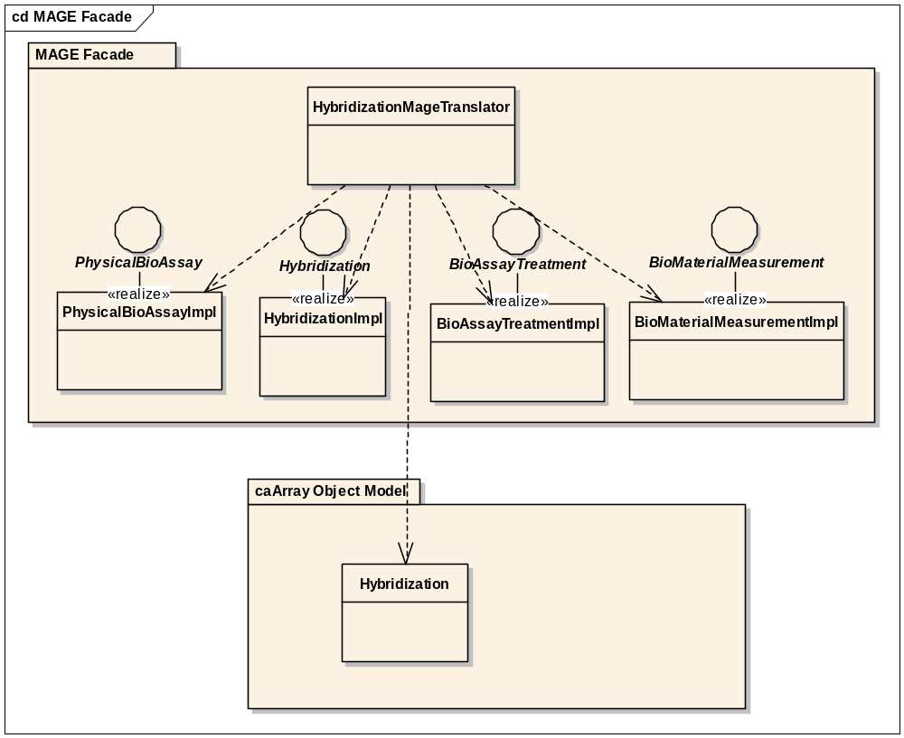
Figure 5 -- MAGE-OM translation from simplified caArray object model

Process View
TBD – the process view will be documented once the major asynchronous components of the system have been identified and designed.

Deployment View
TBD

Implementation View

Overview
Figure 6 below illustrates the major physical artifacts that comprise the caArray software deployment unit.
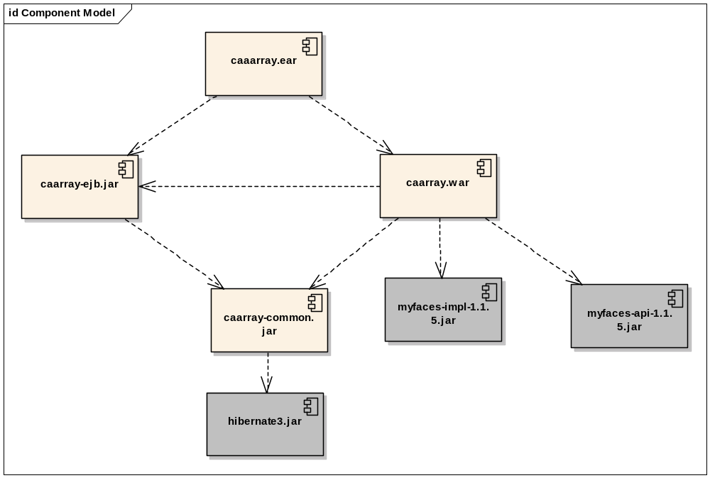
Figure 6—Architecturally Significant Implementation Elements

Layers
Elements in the User Interface layer are allocated to the caarray.war component. Subsystems in the application layer are implemented using EJB 3.0 session and message driven beans as facades to the subsystem functionality. These subsystems are contained in the caarray-ejb.jar component. Business Logic layer elements are allocated to the caarray-common.jar

Data View
TBD

Size and Performance
TBD

Quality
TBD

